UNITED STATES
SECURITIES AND EXCHANGE COMMISSION
Washington, D.C. 20549

FORM 8-K

CURRENT REPORT
Pursuant to Section 13 or 15(d)
of the Securities Exchange Act of 1934

Date of Report (Date of earliest event reported): September 1, 2026

Alumis Inc.
(Exact name of registrant as specified in its charter)

Delaware |  | 001-42143 |  | 86-1771129
(State or other jurisdiction  of incorporation or organization) |  | (Commission  File Number) |  | (I.R.S. Employer  Identification Number)

280 East Grand Avenue
South San Francisco, California 94080

Registrant’s telephone number, including area code: (650) 231-6625

N/A
(Former name or former address, if changed since last report.)

Check the appropriate box below if the Form 8-K filing is intended to simultaneously satisfy the filing obligation of the registrant under any of the following provisions:

☐ | Written communications pursuant to Rule 425 under the Securities Act (17 CFR 230.425)

☐ | Soliciting material pursuant to Rule 14a-12 under the Exchange Act (17 CFR 240.14a-12)

☐ | Pre-commencement communications pursuant to Rule 14d-2(b) under the Exchange Act (17 CFR 240.14d-2(b))

☐ | Pre-commencement communications pursuant to Rule 13e-4(c) under the Exchange Act (17 CFR 240.13e-4(c))

Securities registered pursuant to Section 12(b) of the Act:

Title of each class |  | Trading  Symbol(s) |  | Name of each exchange  on which registered
Common Stock, $0.0001 par value per share |  | ALMS |  | The Nasdaq Global Select Market

Indicate by check mark whether the registrant is an emerging growth company as defined in Rule 405 of the Securities Act of 1933 (§230.405 of this chapter) or Rule 12b-2 of the Securities Exchange Act of 1934 (§240.12b-2 of this chapter).

Emerging growth company x

If an emerging growth company, indicate by check mark if the registrant has elected not to use the extended transition period for complying with any new or revised financial accounting standards provided pursuant to Section 13(a) of the Exchange Act. ☐

Item 8.01 Other Events.

On September 1, 2026, Alumis Inc. (the “Company” or “Alumis”) issued a press release titled “Alumis Announces Topline Results from Envudeucitinib Phase 2b Trial in Systemic Lupus Erythematosus (SLE).”

The Company is also filing slides presented by the Company at a webcast regarding the LUMUS Phase 2b topline results on September 1, 2026.

Copies of the press release and presentation are filed as Exhibit 99.1 and Exhibit 99.2, respectively, to this Current Report on Form 8-K (the “Report”) and are incorporated by reference.

The information contained in the presentation is summary information that is intended to be considered in the context of the more complete information included in the Company’s filings with the Securities and Exchange Commission (“SEC”) and other public announcements that the Company has made and may make from time to time by press release or otherwise. The Company undertakes no duty or obligation to update or revise the information contained in the presentation in this Report, although it may do so from time to time as its management believes is appropriate. Any such update may be made through the filing of other reports or documents with the SEC.

Forward-Looking Statements

This Report contains forward-looking statements within the meaning of federal securities laws, including the “safe harbor” provisions of the Private Securities Litigation Reform Act of 1995. Forward-looking statements generally may be identified by words such as “aims,” “anticipates,” “believes,” “could,” “estimates,” “expects,” “forecasts,” “goal,” “intends,” “may,” “plans,” “possible,” “potential,” “seeks,” “will” and similar expressions intended to identify forward-looking statements. All statements contained in this Report other than statements of historical facts are forward-looking statements, including without limitation statements regarding: Alumis’ plans to submit an NDA for envudeucitinib in the fourth quarter of 2026; anticipated regulatory interactions in systemic lupus erythematosus, including the potential for prespecified subgroup analyses to inform future Phase 3 development; the therapeutic potential of TYK2 inhibition across immune-mediated diseases and the potential multi-indication opportunity for envudeucitinib in interferon-driven diseases, including cutaneous lupus erythematosus and Sjögren’s disease; the development of A-005 for neuroinflammatory and neurodegenerative diseases, including Parkinson’s Disease; the advancement of Alumis’ clinical pipeline; Alumis’ plans to evaluate opportunities to maximize the value of the Company’s TYK2 portfolio and Alumis’ future plans, strategy, prospects and anticipated milestones, as well as the assumptions underlying any of the foregoing. Forward-looking statements are based on Alumis’ current expectations, estimates, assumptions and projections as of the date of this Report and are subject to significant risks and uncertainties that could cause actual results to differ materially and adversely from those expressed or implied by such statements. Readers are cautioned that actual results, timing, safety, efficacy, performance or events and circumstances may differ materially from those expressed or implied in Alumis’ forward-looking statements due to a variety of risks and uncertainties including, without limitation, whether regulatory authorities accept for filing Alumis’ planned NDA submission as well as determine that envudeucitinib demonstrates an acceptable safety and efficacy profile and grant regulatory approval in moderate-to-severe plaque psoriasis; whether clinical results observed to date, including subgroup analyses, will be replicated in larger or later-stage clinical trials; the potential for envudeucitinib to be developed in additional indications; the timing and results of clinical trials; Alumis’ ability to obtain regulatory approval of and ultimately commercialize its product candidates, Alumis’ ability to obtain sufficient funding and achieve anticipated development objectives, and Alumis’ ability to obtain, maintain and enforce intellectual property protection for its programs and product candidates. Additional information regarding these and other risks and uncertainties are contained under the heading “Risk Factors” and elsewhere in Alumis’ filings with the SEC, including its most recent Annual Report on Form 10-K, Quarterly Reports on Form 10-Q, and subsequent filings with the SEC. Alumis explicitly disclaims any obligation to update any forward-looking statements, whether as a result of new information, future events or otherwise, except to the extent required by law.

Item 9.01 Financial Statements and Exhibits.

(d) Exhibits.

Exhibit No. |  | Description
99.1 |  | Press Release, dated September 1, 2026.
99.2 |  | LUMUS Phase 2b Topline Results Presentation, dated September 1, 2026.
104 |  | Cover Page Interactive Data File (embedded within the Inline XBRL document).

SIGNATURES

Pursuant to the requirements of the Securities Exchange Act of 1934, the registrant has duly caused this report to be signed on its behalf by the undersigned hereunto duly authorized.

 | Alumis Inc.
 | By: | /s/ Martin Babler
 |  | Martin Babler
 |  | President & Chief Executive Officer

Dated: September 1, 2026

Exhibit 99.1



Alumis Announces Topline Results from Envudeucitinib Phase 2b Trial in Systemic Lupus Erythematosus (SLE)

– LUMUS trial did not meet its primary and secondary endpoints in the overall trial population –

– Robust responses in the prespecified subgroup of patients with high interferon gene signature (IFNGS-high) support moving forward with Phase 3 development in SLE –

– Pharmacodynamic data substantiate envudeucitinib’s potential in interferon-driven immune-mediated diseases –

– Envudeucitinib was generally well tolerated with no new safety signals observed –

– Alumis remains on track to submit an NDA for envudeucitinib in moderate-to-severe plaque psoriasis in 4Q 2026 –

– Conference call and webcast scheduled for September 1 at 8:30 am EDT –

SOUTH SAN FRANCISCO, Calif., September 1, 2026 – Alumis Inc. (Nasdaq: ALMS), a late-stage biopharmaceutical company developing next-generation targeted therapies for patients with immune-mediated diseases, today announced that its Phase 2b LUMUS trial of envudeucitinib for the treatment of moderate-to-severe systemic lupus erythematosus (SLE) did not meet its primary and secondary endpoints in the overall trial population. Notably, key insights from this trial support a clear path forward for regulatory engagement on Phase 3 development.

Robust clinical responses were observed in a prespecified subgroup analysis of patients with high interferon gene signature (IFNGS-high), including on the primary endpoint, British Isles Lupus Assessment Group–based Composite Lupus Assessment (BICLA), and key secondary efficacy endpoints including Cutaneous Lupus Erythematosus Disease Area and Severity Index 50 (CLASI-50), SLE Responder Index 4 (SRI-4), and Lupus Low Disease Activity State (LLDAS). Patients were classified in LUMUS as IFNGS-high or IFNGS-low using a commercially available interferon gene signature assay.

IFNGS-high patients, a well-defined group representing the majority of moderate-to-severe SLE cases, typically respond more favorably to interferon pathway-targeted therapies and show lower placebo response rates. In LUMUS, IFNGS-high patients were unexpectedly under-represented, reducing response rates in the overall trial population.

"We are extremely grateful to the patients, families, and investigators whose participation made the LUMUS study possible,” said Dr. Jörn Drappa, Chief Medical Officer of Alumis. “Although envudeucitinib did not meet its primary objective in the overall trial population, the magnitude of effect observed in the prespecified IFNGS-high subgroup is highly compelling in a disease with no targeted oral therapies currently available. We plan to engage regulators to discuss Phase 3 development for envudeucitinib.”

Patient pharmacodynamic data confirmed robust dose-dependent interferon-pathway target engagement, with maximal suppression observed at the highest dose, 40mg twice-daily, further supporting envudeucitinib’s inhibition of the intended biological pathway and its potential in interferon-driven immune-mediated diseases. In LUMUS, envudeucitinib was well tolerated and demonstrated a favorable safety profile with no new safety signals.

“The mechanism validated by these data underscores a multi-indication opportunity for envudeucitinib across Type I interferon-driven diseases, including cutaneous lupus erythematosus and Sjögren’s disease,” said Martin Babler, Chief Executive Officer of Alumis. “We are actively evaluating opportunities to maximize the value of our oral TYK2 portfolio and remain on track to file an NDA for envudeucitinib in moderate-to-severe plaque psoriasis in the fourth quarter of this year.”

Conference Call, Presentation and Webcast Details
Alumis will host a webcast for the investment community to review the Phase 2 LUMUS results which will begin at 5:30 am PDT / 8:30 am EDT on Tuesday, September 1, 2026. The live webcast can be accessed via this link or on the Events tab on the Investors section of the Company’s website. A replay of the webcast will be made available on the Company’s website following the call.

About the LUMUS Phase 2b Trial
The global LUMUS Phase 2b trial (NCT05966480) is a randomized, double-blind, placebo-controlled study evaluating multiple doses of envudeucitinib in adults with moderately-to-severely active, autoantibody-positive systemic lupus erythematosus (SLE). The trial enrolled 408 patients who received one of three envudeucitinib doses or placebo for 48 weeks in Part A. The primary endpoint was the assessment of improvements in overall disease activity using the British Isles Lupus Assessment Group-based Composite Lupus Assessment (BICLA) at Week 48. Select secondary endpoints assessed at Week 48 include safety and tolerability, corticosteroid use, and disease activity measured by Cutaneous Lupus Erythematosus Disease Area and Severity Index (CLASI) and SLE Responder Index-4 (SRI-4). After Part A, eligible patients could complete a four-week safety follow-up or participate in LUMUS Part B, a long-term open label extension study.

About Envudeucitinib
Envudeucitinib is a next-generation, highly selective, oral allosteric inhibitor of tyrosine kinase 2 (TYK2) precision-engineered for maximal 24-hour TYK2 inhibition to correct immune dysregulation across a range of diseases driven by IL-23, IL-17, and Type I interferon. It is the only TYK2 inhibitor shown to deliver maximal target inhibition over 24 hours in humans, with clinical data demonstrating sustained TYK2 blockade in patients with psoriasis while minimizing off-target binding and effects. Envudeucitinib has been administered with or without food, with no fasting requirement. Alumis has reported positive results from its Phase 3 ONWARD program of envudeucitinib in moderate-to-severe plaque psoriasis and plans to file an NDA in moderate-to-severe plaque psoriasis in the fourth quarter of 2026.

About TYK2 in Immune-Mediated Disease
Tyrosine kinase 2 (TYK2) is a key immune-signaling enzyme that regulates pathways across innate and adaptive immunity, including the IL-23/IL-17 axis and Type I interferon signaling that drive many high-burden immune-mediated diseases. Selective TYK2 inhibition has been widely validated as an effective, safe, and well-tolerated therapeutic approach. Genomic analyses conducted by Alumis highlight TYK2’s broad therapeutic potential, showing that it contributes to the pathogenesis of roughly 20 immune-driven conditions - including psoriasis, lupus, Sjögren’s disease, cutaneous lupus erythematosus, psoriatic arthritis, Crohn’s disease, and ulcerative colitis. Additional evidence supports a genetic rationale for TYK2 inhibition in neuroinflammatory and neurodegenerative diseases where targeting TYK2 may offer a novel approach to treatment.

About Alumis
Alumis is a late-stage biopharma company developing next-generation targeted therapies with the potential to significantly improve patient health and outcomes across a range of immune-mediated diseases. Leveraging its proprietary data analytics platform and precision approach, Alumis is developing a pipeline of oral tyrosine kinase 2 inhibitors, consisting of envudeucitinib for the treatment of systemic immune-mediated disorders, such as moderate-to-severe plaque psoriasis and systemic lupus erythematosus, and A-005 for the treatment of neuroinflammatory and neurodegenerative diseases, such as Parkinson’s disease. In addition, the pipeline includes several preclinical programs identified through this precision approach. For more information, visit www.alumis.com or follow us on LinkedIn or X.

Forward-Looking Statements
This press release contains forward-looking statements within the meaning of federal securities laws, including the “safe harbor” provisions of the Private Securities Litigation Reform Act of 1995. Forward-looking statements generally may be identified by words such as "aims," "anticipates," "believes," "could," "estimates," "expects," "forecasts," "goal," "intends," "may," "plans," "possible," "potential," "seeks," "will" and similar expressions intended to identify forward-looking statements. All statements contained in this press release other than statements of historical facts are forward-looking statements, including without limitation statements regarding: Alumis’ plans to submit an NDA for envudeucitinib in the fourth quarter of 2026; anticipated regulatory interactions in systemic lupus erythematosus, including the potential for prespecified subgroup analyses to inform future Phase 3 development; the therapeutic potential of TYK2 inhibition across immune-mediated diseases and the potential multi-indication opportunity for envudeucitinib in interferon-driven diseases, including cutaneous lupus erythematosus and Sjögren's disease; the development of A-005 for neuroinflammatory and neurodegenerative diseases, including Parkinson’s Disease; the advancement of Alumis’ clinical pipeline; Alumis' plans to evaluate opportunities to maximize the value of the company’s TYK2 portfolio and Alumis’ future plans, strategy, prospects and anticipated milestones, as well as the assumptions underlying any of the foregoing. Forward-looking statements are based on Alumis’ current expectations, estimates, assumptions and projections as of the date of this press release and are subject to significant risks and uncertainties that could cause actual results to differ materially and adversely from those expressed or implied by such statements. Readers are cautioned that actual results, timing, safety, efficacy, performance or events and circumstances may differ materially from those expressed or implied in Alumis’ forward-looking statements due to a variety of risks and uncertainties including, without limitation, whether regulatory authorities accept for filing Alumis’ planned NDA submission as well as determine that envudeucitinib demonstrates an acceptable safety and efficacy profile and grant regulatory approval in moderate-to-severe plaque psoriasis; whether clinical results observed to date, including subgroup analyses, will be replicated in larger or later-stage clinical trials; the potential for envudeucitinib to be developed in additional indications; the timing and results of clinical trials; Alumis’ ability to obtain regulatory approval of and ultimately commercialize its product candidates, Alumis’ ability to obtain sufficient funding and achieve anticipated development objectives, and Alumis’ ability to obtain, maintain and enforce intellectual property protection for its programs and product candidates. Additional information regarding these and other risks and uncertainties are contained under the heading “Risk Factors” and elsewhere in Alumis’ filings with the Securities and Exchange Commission (SEC) , including its most recent Annual Report on Form 10-K, Quarterly Reports on Form 10-Q, and subsequent filings with the SEC. Alumis explicitly disclaims any obligation to update any forward-looking statements, whether as a result of new information, future events or otherwise, except to the extent required by law.

Alumis Contact Information
Teri Dahlman, Red House Communications
teri@redhousecomms.com

Exhibit 99.2

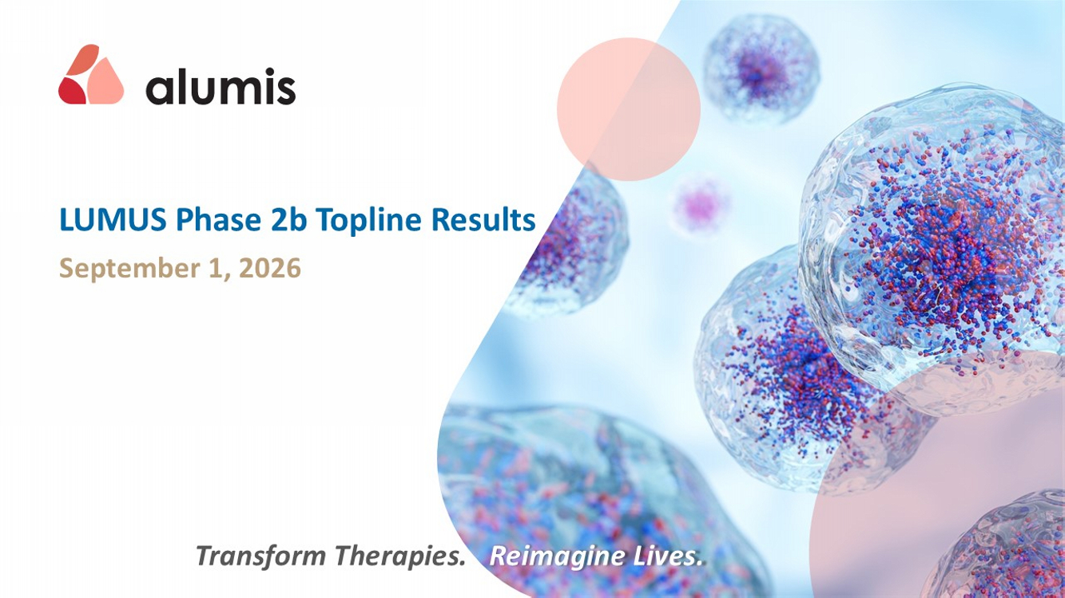
Transform Therapies. Reimagine Lives. LUMUS Phase 2b Topline Results September 1, 2026

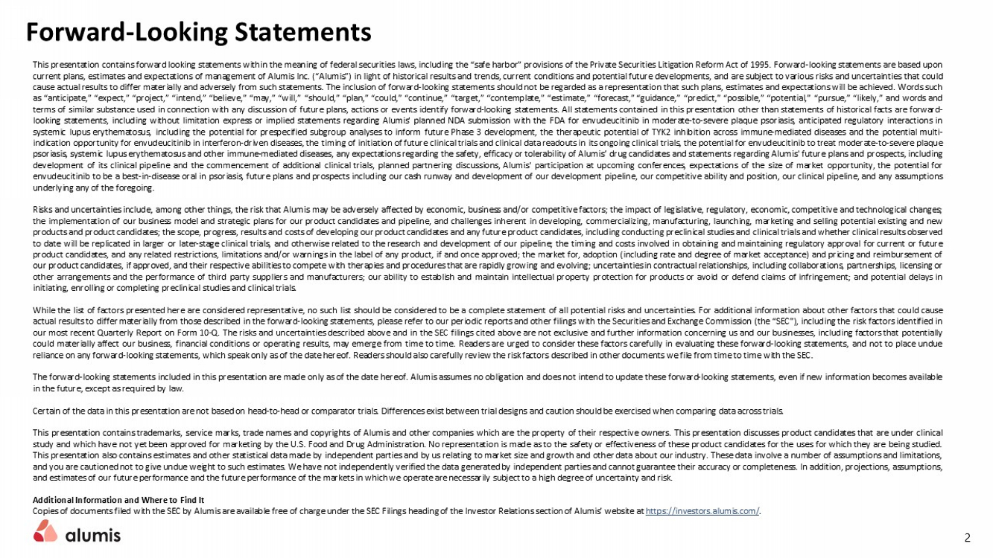
Forward - Looking Statements This presentation contains forward looking statements within the meaning of federal securities laws, including the “safe harbor” provisions of the Private Securities Litigation Reform Act of 1995 . Forward - looking statements are based upon current plans, estimates and expectations of management of Alumis Inc . (“ Alumis ”) in light of historical results and trends, current conditions and potential future developments, and are subject to various risks and uncertainties that could cause actual results to differ materially and adversely from such statements . The inclusion of forward - looking statements should not be regarded as a representation that such plans, estimates and expectations will be achieved . Words such as “anticipate,” “expect,” “project,” “intend,” “believe,” “may,” “will,” “should,” “plan,” “could,” “continue,” “target,” “contemplate,” “estimate,” “forecast,” “guidance,” “predict,” “possible,” “potential,” “pursue,” “likely,” and words and terms of similar substance used in connection with any discussion of future plans, actions or events identify forward - looking statements . All statements contained in this presentation other than statements of historical facts are forward - looking statements, including without limitation express or implied statements regarding Alumis ' planned NDA submission with the FDA for envudeucitinib in moderate - to - severe plaque psoriasis, anticipated regulatory interactions in systemic lupus erythematosus, including the potential for prespecified subgroup analyses to inform future Phase 3 development, the therapeutic potential of TYK 2 inhibition across immune - mediated diseases and the potential multi - indication opportunity for envudeucitinib in interferon - driven diseases, the timing of initiation of future clinical trials and clinical data readouts in its ongoing clinical trials, the potential for envudeucitinib to treat moderate - to - severe plaque psoriasis, systemic lupus erythematosus and other immune - mediated diseases, any expectations regarding the safety, efficacy or tolerability of Alumis ’ drug candidates and statements regarding Alumis ' future plans and prospects, including development of its clinical pipeline and the commencement of additional clinical trials , planned partnering discussions, Alumis ' participation at upcoming conferences , expectations of the size of market opportunity, the potential for envudeucitinib to be a best - in - disease oral in psoriasis, future plans and prospects including our cash runway and development of our development pipeline, our competitive ability and position, our clinical pipeline, and any assumptions underlying any of the foregoing . Risks and uncertainties include, among other things, the risk that Alumis may be adversely affected by economic, business and/or competitive factors ; the impact of legislative, regulatory, economic, competitive and technological changes ; the implementation of our business model and strategic plans for our product candidates and pipeline, and challenges inherent in developing, commercializing, manufacturing, launching, marketing and selling potential existing and new products and product candidates ; the scope, progress, results and costs of developing our product candidates and any future product candidates, including conducting preclinical studies and clinical trials and whether clinical results observed to date will be replicated in larger or later - stage clinical trials, and otherwise related to the research and development of our pipeline ; the timing and costs involved in obtaining and maintaining regulatory approval for current or future product candidates, and any related restrictions, limitations and/or warnings in the label of any product, if and once approved ; the market for, adoption (including rate and degree of market acceptance) and pricing and reimbursement of our product candidates, if approved, and their respective abilities to compete with therapies and procedures that are rapidly growing and evolving ; uncertainties in contractual relationships, including collaborations, partnerships, licensing or other arrangements and the performance of third party suppliers and manufacturers ; our ability to establish and maintain intellectual property protection for products or avoid or defend claims of infringement ; and potential delays in initiating, enrolling or completing preclinical studies and clinical trials . While the list of factors presented here are considered representative, no such list should be considered to be a complete statement of all potential risks and uncertainties . For additional information about other factors that could cause actual results to differ materially from those described in the forward - looking statements, please refer to our periodic reports and other filings with the Securities and Exchange Commission (the “SEC”), including the risk factors identified in our most recent Quarterly Report on Form 10 - Q . The risks and uncertainties described above and in the SEC filings cited above are not exclusive and further information concerning us and our businesses, including factors that potentially could materially affect our business, financial conditions or operating results, may emerge from time to time . Readers are urged to consider these factors carefully in evaluating these forward - looking statements, and not to place undue reliance on any forward - looking statements, which speak only as of the date hereof . Readers should also carefully review the risk factors described in other documents we file from time to time with the SEC . The forward - looking statements included in this presentation are made only as of the date hereof . Alumis assumes no obligation and does not intend to update these forward - looking statements, even if new information becomes available in the future, except as required by law . Certain of the data in this presentation are not based on head - to - head or comparator trials . Differences exist between trial designs and caution should be exercised when comparing data across trials . This presentation contains trademarks, service marks, trade names and copyrights of Alumis and other companies which are the property of their respective owners . This presentation discusses product candidates that are under clinical study and which have not yet been approved for marketing by the U . S . Food and Drug Administration . No representation is made as to the safety or effectiveness of these product candidates for the uses for which they are being studied . This presentation also contains estimates and other statistical data made by independent parties and by us relating to market size and growth and other data about our industry . These data involve a number of assumptions and limitations, and you are cautioned not to give undue weight to such estimates . We have not independently verified the data generated by independent parties and cannot guarantee their accuracy or completeness . In addition, projections, assumptions, and estimates of our future performance and the future performance of the markets in which we operate are necessarily subject to a high degree of uncertainty and risk . Additional Information and Where to Find It Copies of documents filed with the SEC by Alumis are available free of charge under the SEC Filings heading of the Investor Relations section of Alumis ’ website at https : //investors . alumis . com/ . 2

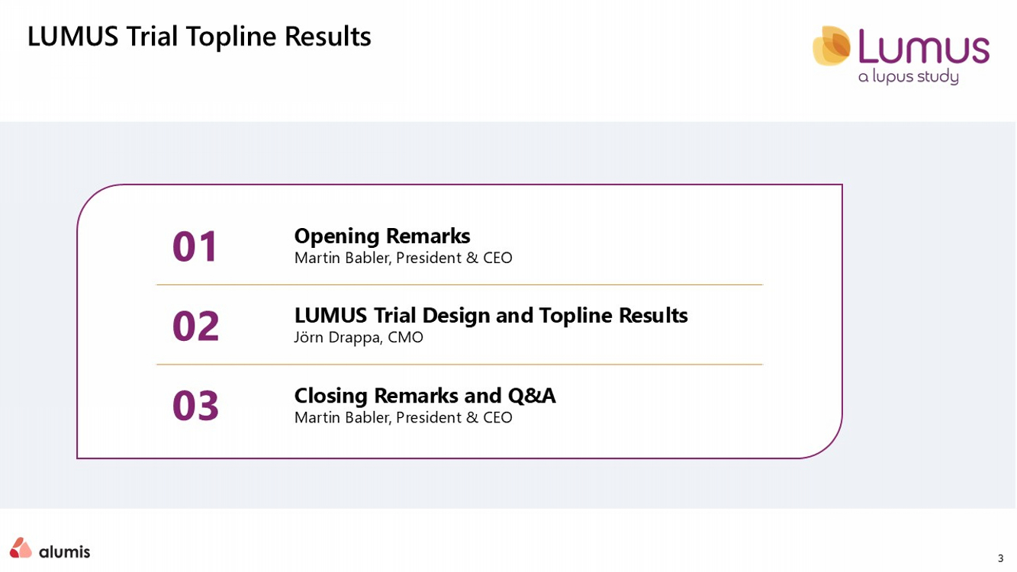
3 LUMUS Trial Topline Results Opening Remarks Martin Babler, President & CEO 01 LUMUS Trial Design and Topline Results Jörn Drappa , CMO 02 Closing Remarks and Q&A Martin Babler, President & CEO 03

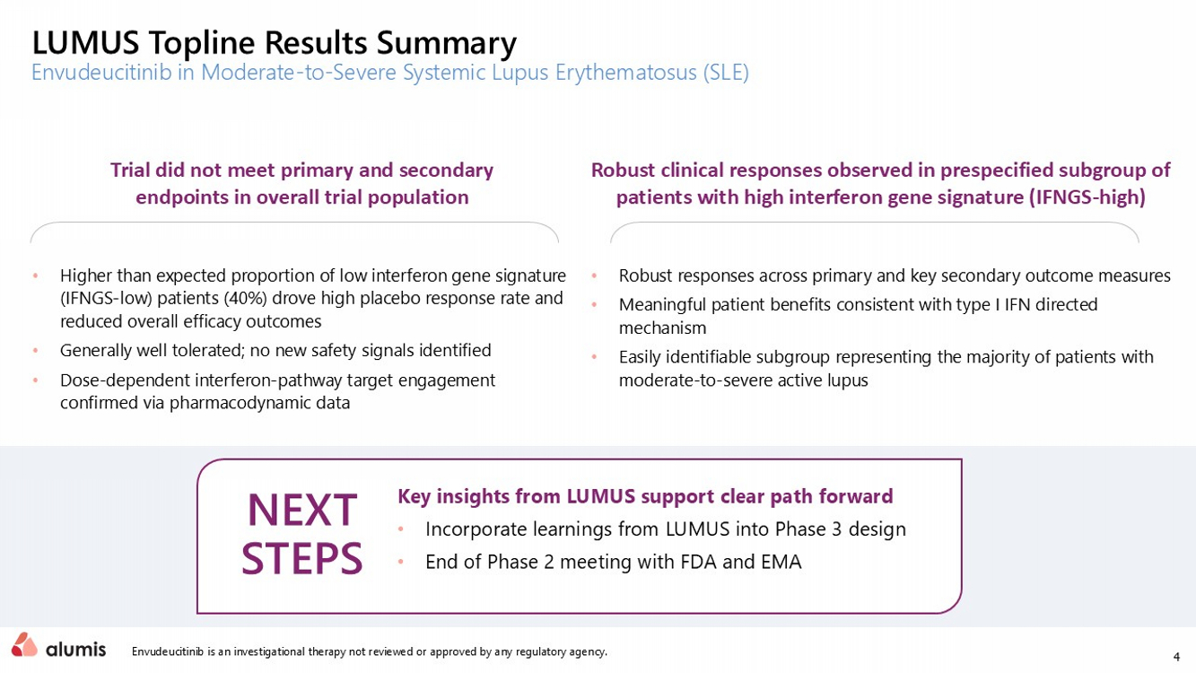
4 Envudeucitinib is an investigational therapy not reviewed or approved by any regulatory agency. LUMUS Topline Results Summary Envudeucitinib in Moderate - to - Severe Systemic Lupus Erythematosus (SLE) NEXT STEPS Key insights from LUMUS support clear path forward • Incorporate learnings from LUMUS into Phase 3 design • End of Phase 2 meeting with FDA and EMA Trial did not meet primary and secondary endpoints in overall trial population • Higher than expected proportion of low interferon gene signature (IFNGS - low) patients (40%) drove high placebo response rate and reduced overall efficacy outcomes • Generally well tolerated; no new safety signals identified • Dose - dependent interferon - pathway target engagement confirmed via pharmacodynamic data Robust clinical responses observed in prespecified subgroup of patients with high interferon gene signature (IFNGS - high) • Robust responses across primary and key secondary outcome measures​ • Meaningful patient benefits consistent with type I IFN directed mechanism​ • Easily identifiable subgroup representing the majority of patients with moderate - to - severe active lupus​

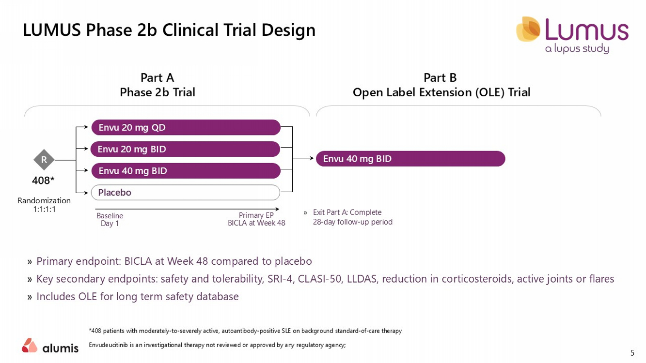
LUMUS Phase 2b Clinical Trial Design *408 patients with moderately - to - severely active, autoantibody - positive SLE on background standard - of - care therapy Envudeucitinib is an investigational therapy not reviewed or approved by any regulatory agency; Placebo Envu 20 mg BID Envu 40 mg BID Envu 20 mg QD » Primary endpoint: BICLA at Week 48 compared to placebo » Key secondary endpoints: safety and tolerability, SRI - 4, CLASI - 50 , LLDAS, reduction in corticosteroids, active joints or flares » Includes OLE for long term safety database Envu 40 mg BID Randomization 1:1:1:1 Baseline Day 1 Primary EP BICLA at Week 48 R Part A Phase 2b Trial Part B Open Label Extension (OLE) Trial 408* » Exit Part A : Complete 28 - day follow - up period 5

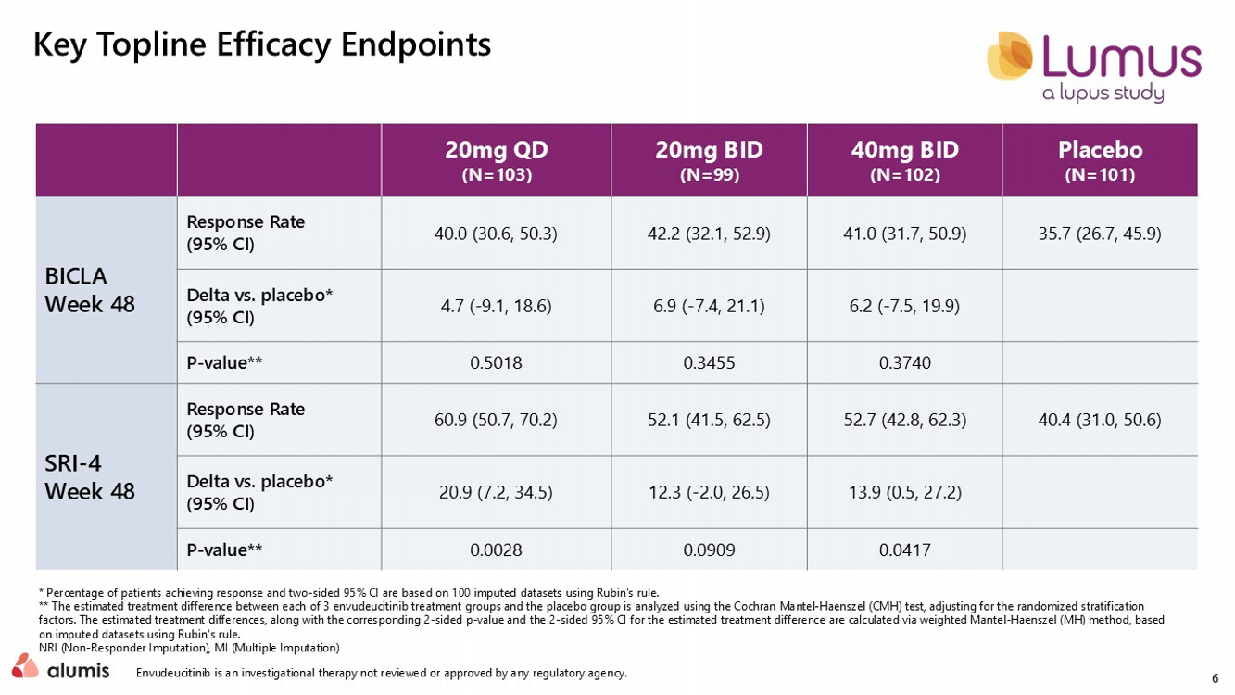
6 * Percentage of patients achieving response and two - sided 95% CI are based on 100 imputed datasets using Rubin's rule.​ ** The estimated treatment difference between each of 3 envudeucitinib treatment groups and the placebo group is analyzed using the Cochran Mantel - Haenszel (CMH) test, adjusting for the randomized s tratification factors. The estimated treatment differences, along with the corresponding 2 - sided p - value and the 2 - sided 95% CI for the estima ted treatment difference are calculated via weighted Mantel - Haenszel (MH) method, based on imputed datasets using Rubin's rule.​ NRI (Non - Responder Imputation), MI (Multiple Imputation)​ Key Topline Efficacy Endpoints Placebo (N=101) 40mg BID (N=102) 20mg BID (N=99) 20mg QD (N=103) 35.7 (26.7, 45.9) 41.0 (31.7, 50.9) 42.2 (32.1, 52.9) 40.0 (30.6, 50.3) Response Rate (95% CI) BICLA Week 48 6.2 ( - 7.5, 19.9) 6.9 ( - 7.4, 21.1) 4.7 ( - 9.1, 18.6) Delta vs. placebo* (95% CI) 0.3740 0.3455 0.5018 P - value** 40.4 (31.0, 50.6) 52.7 (42.8, 62.3) 52.1 (41.5, 62.5) 60.9 (50.7, 70.2) Response Rate (95% CI) SRI - 4 Week 48 13.9 (0.5, 27.2) 12.3 ( - 2.0, 26.5) 20.9 (7.2, 34.5) Delta vs. placebo* (95% CI) 0.0417 0.0909 0.0028 P - value** Envudeucitinib is an investigational therapy not reviewed or approved by any regulatory agency.

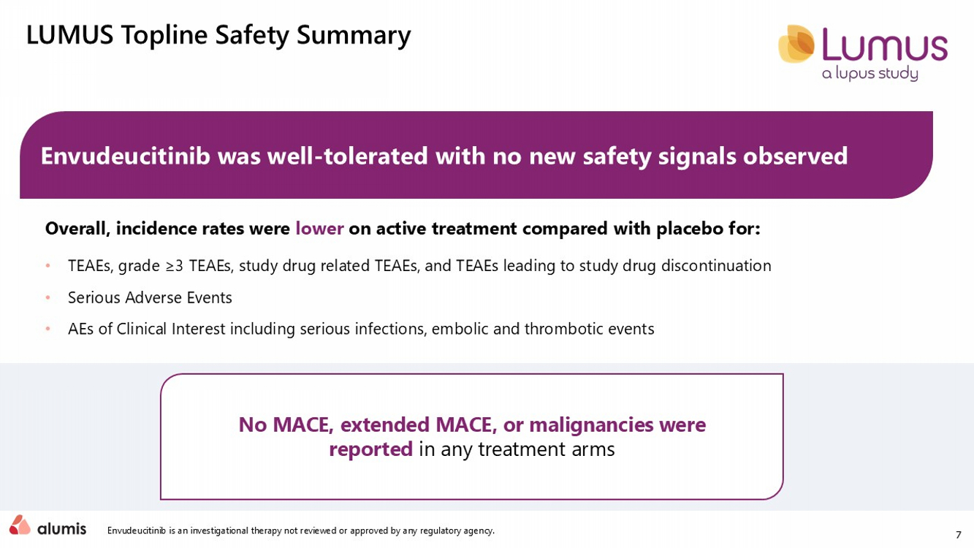
7 Envudeucitinib is an investigational therapy not reviewed or approved by any regulatory agency. LUMUS Topline Safety Summary Envudeucitinib was well - tolerated with no new safety signals observed Overall, incidence rates were lower on active treatment compared with placebo for: • TEAEs, grade ≥3 TEAEs, study drug related TEAEs, and TEAEs leading to study drug discontinuation • Serious Adverse Events • AEs of Clinical Interest including serious infections, embolic and thrombotic events No MACE, extended MACE, or malignancies were reported in any treatment arms

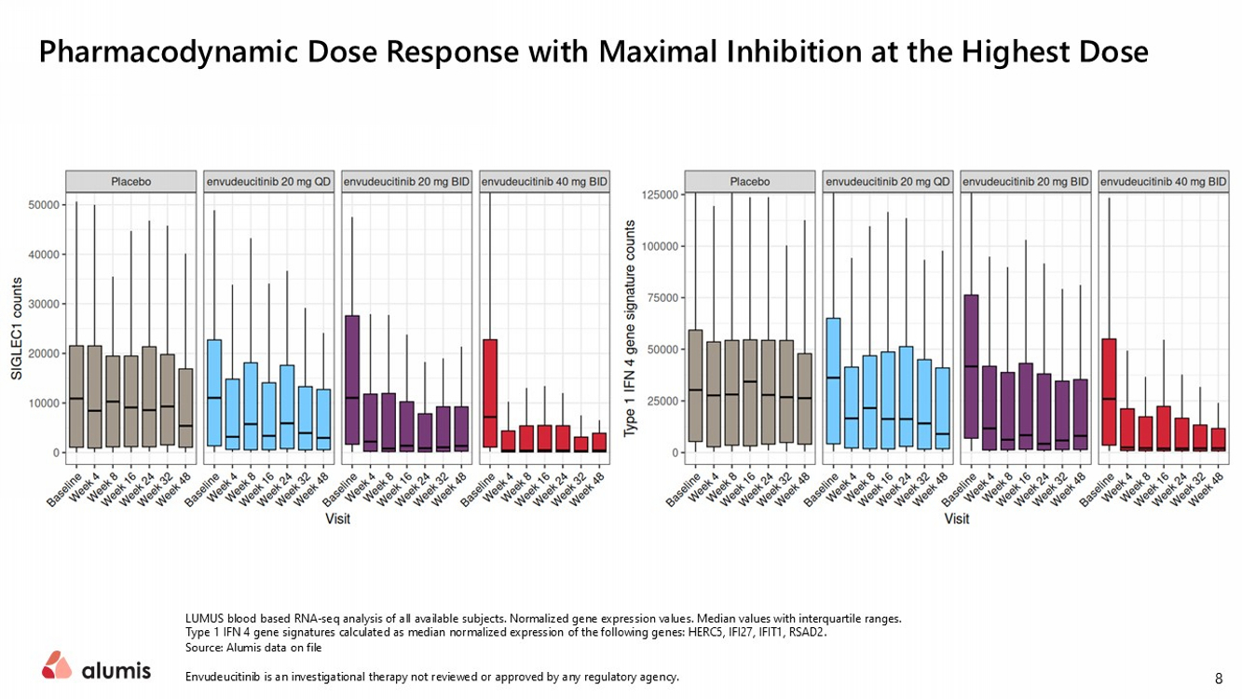
LUMUS blood based RNA - seq analysis of all available subjects. Normalized gene expression values. Median values with interquartil e ranges. Type 1 IFN 4 gene signatures calculated as median normalized expression of the following genes: HERC5, IFI27, IFIT1, RSAD2. Source: Alumis data on file Envudeucitinib is an investigational therapy not reviewed or approved by any regulatory agency. Pharmacodynamic Dose Response with Maximal Inhibition at the Highest Dose 8

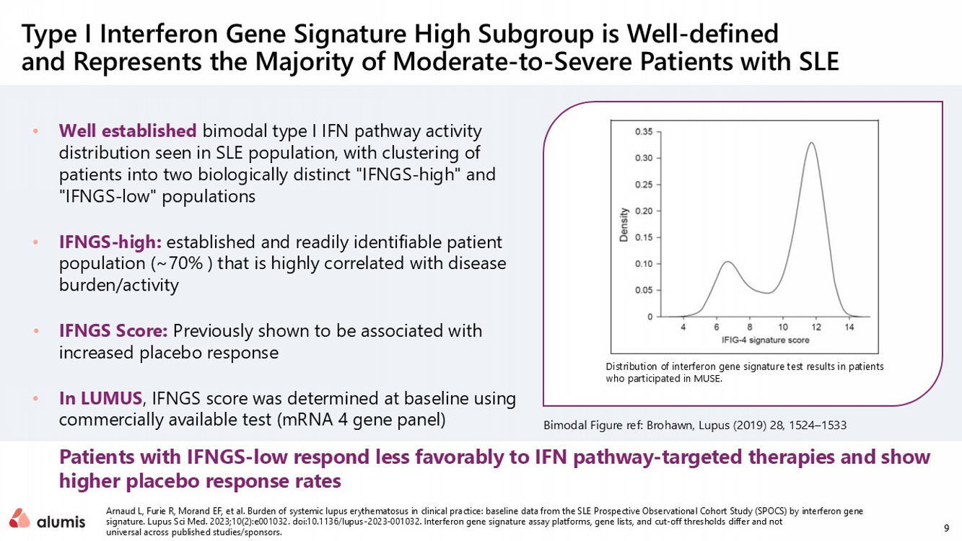
9 • Well established bimodal type I IFN pathway activity distribution seen in SLE population, with clustering of patients into two biologically distinct "IFNGS - high" and "IFNGS - low" populations • IFNGS - high: established and readily identifiable patient population (~70% ) that is highly correlated with disease burden/activity • IFNGS Score: Previously shown to be associated with increased placebo response​ • In LUMUS , IFNGS score was determined at baseline using commercially available test (mRNA 4 gene panel)​ Arnaud L, Furie R, Morand EF, et al. Burden of systemic lupus erythematosus in clinical practice: baseline data from the SLE Pro spective Observational Cohort Study (SPOCS) by interferon gene signature. Lupus Sci Med. 2023;10(2):e001032. doi:10.1136/lupus - 2023 - 001032. Interferon gene signature assay platforms, gene lis ts, and cut - off thresholds differ and not universal across published studies/sponsors. Type I Interferon Gene Signature High Subgroup is Well - defined and Represents the Majority of Moderate - to - Severe Patients with SLE​ Bimodal Figure ref: Brohawn, Lupus (2019) 28, 1524 – 1533 Patients with IFNGS - low respond less favorably to IFN pathway - targeted therapies and show higher placebo response rates Distribution of interferon gene signature test results in patients who participated in MUSE. RR1

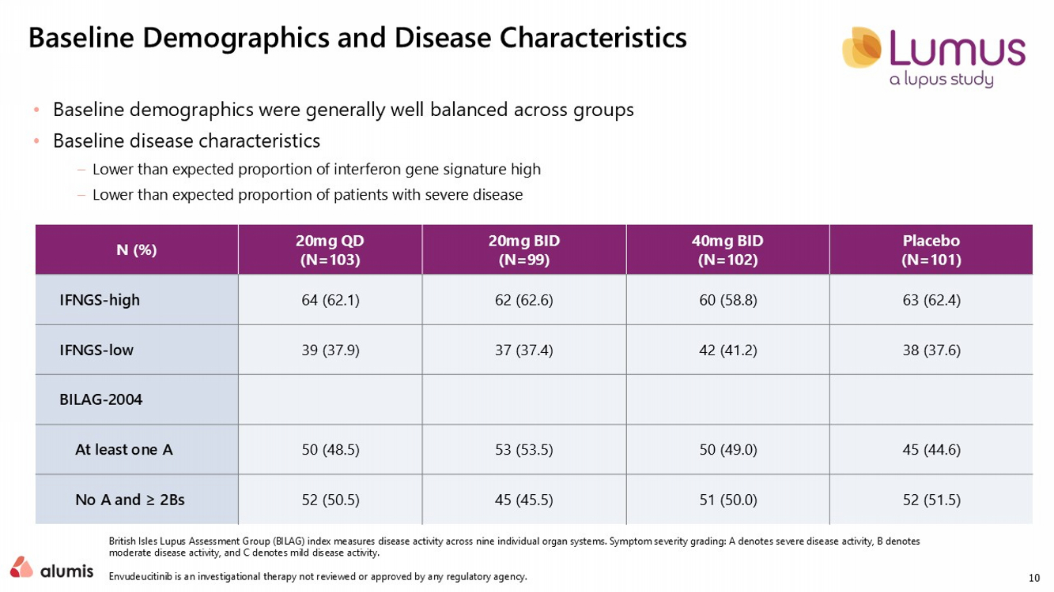
10 • Baseline demographics were generally well balanced across groups • Baseline disease characteristics – Lower than expected proportion of interferon gene signature high – Lower than expected proportion of patients with severe disease British Isles Lupus Assessment Group (BILAG) index measures disease activity across nine individual organ systems. Symptom sever ity grading: A denotes severe disease activity, B denotes moderate disease activity, and C denotes mild disease activity. Envudeucitinib is an investigational therapy not reviewed or approved by any regulatory agency. Baseline Demographics and Disease Characteristics Placebo (N=101) 40mg BID (N=102) 20mg BID (N=99) 20mg QD (N=103) N (%) 63 (62.4) 60 (58.8) 62 (62.6) 64 (62.1) IFNGS - high 38 (37.6) 42 (41.2) 37 (37.4) 39 (37.9) IFNGS - low BILAG - 2004 45 (44.6) 50 (49.0) 53 (53.5) 50 (48.5) At least one A 52 (51.5) 51 (50.0) 45 (45.5) 52 (50.5) No A and ≥ 2Bs

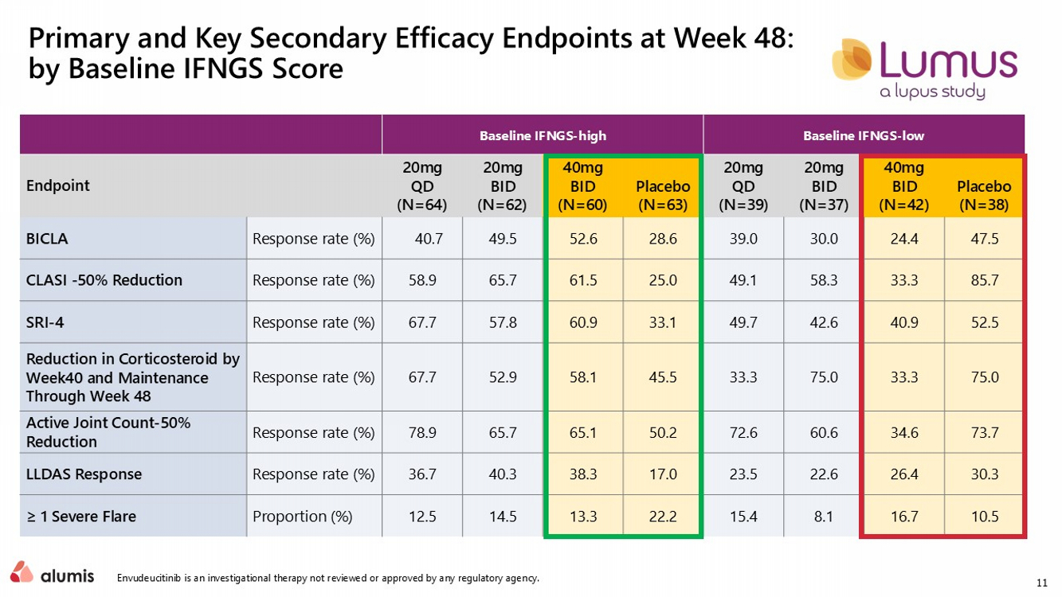
11 Primary and Key Secondary Efficacy Endpoints at Week 48: by Baseline IFNGS Score Baseline IFNGS - low Baseline IFNGS - high Placebo (N=38) 40mg BID (N=42) 20mg BID (N=37) 20mg QD (N=39) Placebo (N=63) 40mg BID (N=60) 20mg BID (N=62) 20mg QD (N=64) Endpoint 47.5 24.4 30.0 39.0 28.6 52.6 49.5 40.7 Response rate (%) BICLA 85.7 33.3 58.3 49.1 25.0 61.5 65.7 58.9 Response rate (%) CLASI - 50% Reduction 52.5 40.9 42.6 49.7 33.1 60.9 57.8 67.7 Response rate (%) SRI - 4 75.0 33.3 75.0 33.3 45.5 58.1 52.9 67.7 Response rate (%) Reduction in Corticosteroid by Week40 and Maintenance Through Week 48 73.7 34.6 60.6 72.6 50.2 65.1 65.7 78.9 Response rate (%) Active Joint Count - 50% Reduction 30.3 26.4 22.6 23.5 17.0 38.3 40.3 36.7 Response rate (%) LLDAS Response 10.5 16.7 8.1 15.4 22.2 13.3 14.5 12.5 Proportion (%) ≥ 1 Severe Flare Envudeucitinib is an investigational therapy not reviewed or approved by any regulatory agency.

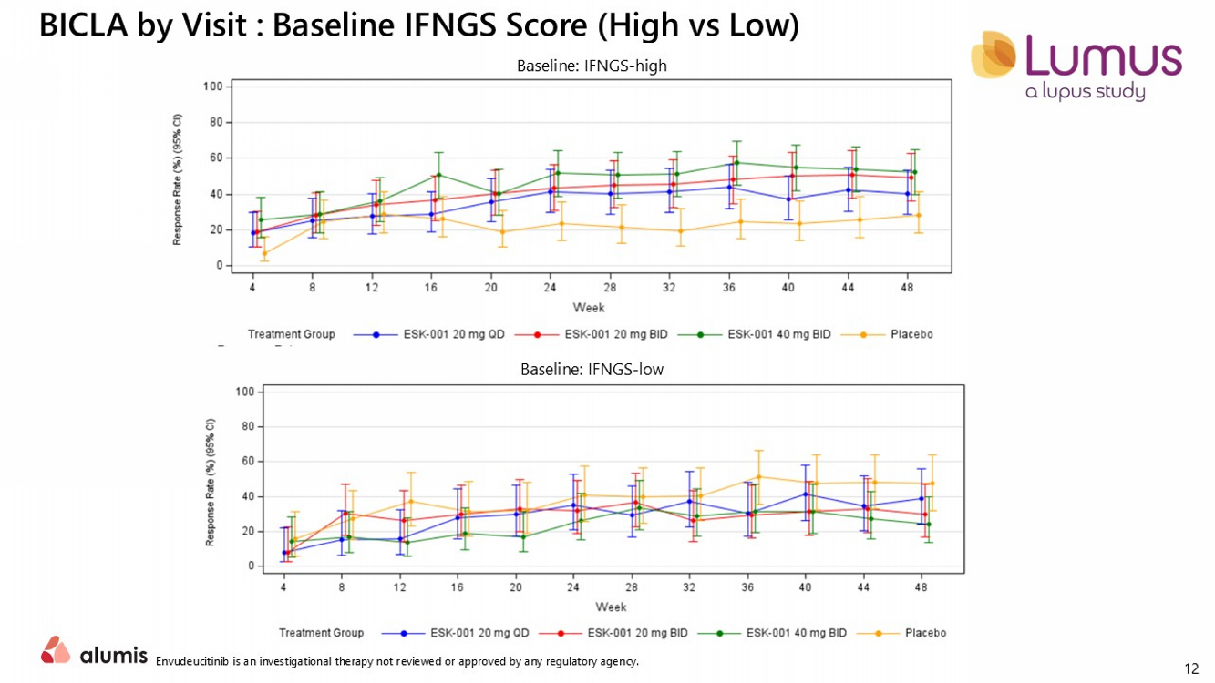
12 BICLA by Visit : Baseline IFNGS Score (High vs Low) Envudeucitinib is an investigational therapy not reviewed or approved by any regulatory agency. Baseline: IFNGS - high Baseline: IFNGS - low

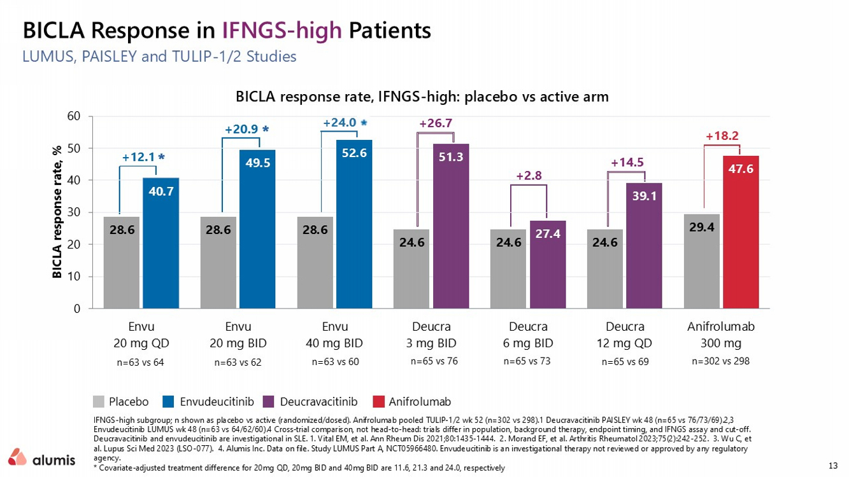
13 LUMUS, PAISLEY and TULIP - 1/2 Studies IFNGS - high subgroup; n shown as placebo vs active (randomized/dosed). Anifrolumab pooled TULIP - 1/2 wk 52 (n=302 vs 298).1 Deucravacitinib PAISLEY wk 48 (n=65 vs 76/73/69).2,3 Envudeucitinib LUMUS wk 48 (n=63 vs 64/62/60).4 Cross - trial comparison, not head - to - head: trials differ in population, background therapy, endpoint tim ing, and IFNGS assay and cut - off. Deucravacitinib and envudeucitinib are investigational in SLE. 1. Vital EM, et al. Ann Rheum Dis 2021;80:1435 - 1444. 2. Morand EF, et al. Arthritis Rheumatol 2023;75(2):242 - 252. 3. Wu C, et al. Lupus Sci Med 2023 (LSO - 077). 4. Alumis Inc. Data on file. Study LUMUS Part A, NCT05966480. Envudeucitinib is an investigational therapy not reviewed or approved by any regulatory agency. * Covariate - adjusted treatment difference​ for 20mg QD, 20mg BID and 40mg BID are 11.6, 21.3 and 24.0, respectively BICLA Response in IFNGS - high Patients +12.1 +20.9 +24.0 +26.7 +2.8 +14.5 +18.2 n=63 vs 64 n=63 vs 62 n=63 vs 60 n=302 vs 298 n=65 vs 76 n=65 vs 73 n=65 vs 69 28.6 28.6 28.6 24.6 24.6 24.6 29.4 40.7 49.5 52.6 51.3 27.4 39.1 47.6 0 10 20 30 40 50 60 Envu 20 mg QD Envu 20 mg BID Envu 40 mg BID Deucra 3 mg BID Deucra 6 mg BID Deucra 12 mg QD Anifrolumab 300 mg BICLA response rate, % BICLA response rate, IFNGS - high: placebo vs active arm Placebo Deucravacitinib Anifrolumab Envudeucitinib

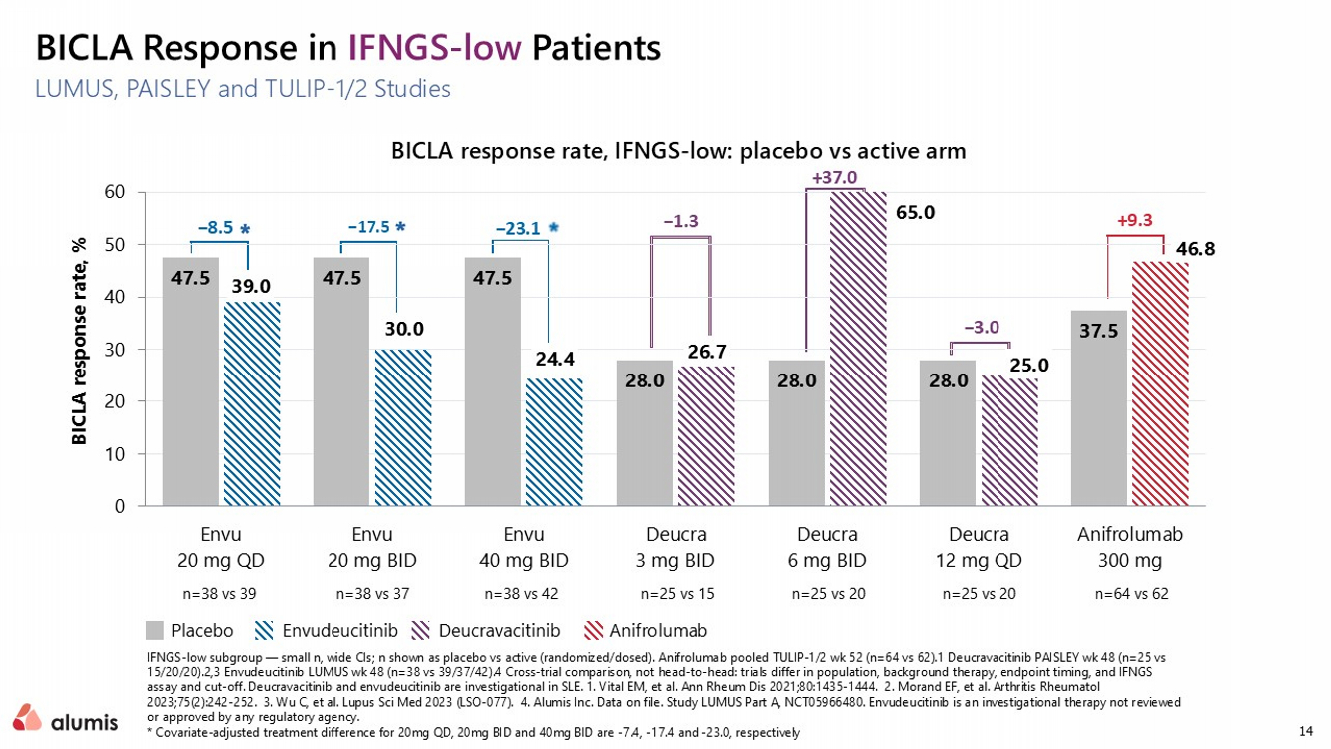
14 LUMUS, PAISLEY and TULIP - 1/2 Studies IFNGS - low subgroup — small n, wide CIs; n shown as placebo vs active (randomized/dosed). Anifrolumab pooled TULIP - 1/2 wk 52 (n=64 vs 62).1 Deucravacitinib PAISLEY wk 48 (n=25 vs 15/20/20).2,3 Envudeucitinib LUMUS wk 48 (n=38 vs 39/37/42).4 Cross - trial comparison, not head - to - head: trials differ in population, background therapy, endpoint tim ing, and IFNGS assay and cut - off. Deucravacitinib and envudeucitinib are investigational in SLE. 1. Vital EM, et al. Ann Rheum Dis 2021;80:1435 - 1444. 2. Morand EF, et al. Arthritis Rheumatol 2023;75(2):242 - 252. 3. Wu C, et al. Lupus Sci Med 2023 (LSO - 077). 4. Alumis Inc. Data on file. Study LUMUS Part A, NCT05966480. Envudeucitinib is an investigational therapy not reviewed or approved by any regulatory agency. * Covariate - adjusted treatment difference​ for 20mg QD, 20mg BID and 40mg BID are - 7.4, - 17.4 and - 23.0, respectively BICLA Response in IFNGS - low Patients −8.5 −17.5 −23.1 −1.3 +37.0 −3.0 +9.3 n=38 vs 39 n=38 vs 37 n=38 vs 42 n=64 vs 62 n=25 vs 15 n=25 vs 20 n=25 vs 20 47.5 47.5 47.5 28.0 28.0 28.0 37.5 39.0 30.0 24.4 26.7 65.0 25.0 46.8 0 10 20 30 40 50 60 Envu 20 mg QD Envu 20 mg BID Envu 40 mg BID Deucra 3 mg BID Deucra 6 mg BID Deucra 12 mg QD Anifrolumab 300 mg BICLA response rate, % BICLA response rate, IFNGS - low: placebo vs active arm Placebo Deucravacitinib Anifrolumab Envudeucitinib

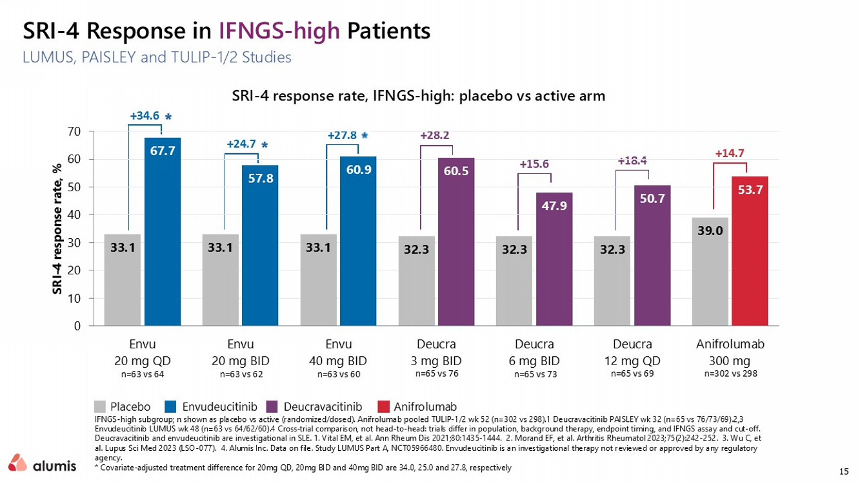
15 LUMUS, PAISLEY and TULIP - 1/2 Studies IFNGS - high subgroup; n shown as placebo vs active (randomized/dosed). Anifrolumab pooled TULIP - 1/2 wk 52 (n=302 vs 298).1 Deucravacitinib PAISLEY wk 32 (n=65 vs 76/73/69).2,3 Envudeucitinib LUMUS wk 48 (n=63 vs 64/62/60).4 Cross - trial comparison, not head - to - head: trials differ in population, background therapy, endpoint tim ing, and IFNGS assay and cut - off. Deucravacitinib and envudeucitinib are investigational in SLE. 1. Vital EM, et al. Ann Rheum Dis 2021;80:1435 - 1444. 2. Morand EF, et al. Arthritis Rheumatol 2023;75(2):242 - 252. 3. Wu C, et al. Lupus Sci Med 2023 (LSO - 077). 4. Alumis Inc. Data on file. Study LUMUS Part A, NCT05966480. Envudeucitinib is an investigational therapy not reviewed or approved by any regulatory agency. * Covariate - adjusted treatment difference​ for 20mg QD, 20mg BID and 40mg BID are 34.0, 25.0 and 27.8, respectively SRI - 4 Response in IFNGS - high Patients +34.6 +24.7 +27.8 +28.2 +15.6 +18.4 +14.7 n=63 vs 64 n=63 vs 62 n=63 vs 60 n=302 vs 298 n=65 vs 76 n=65 vs 73 n=65 vs 69 Placebo Deucravacitinib Anifrolumab Envudeucitinib SRI - 4 response rate, IFNGS - high: placebo vs active arm 33.1 33.1 33.1 32.3 32.3 32.3 39.0 67.7 57.8 60.9 60.5 47.9 50.7 53.7 0 10 20 30 40 50 60 70 Envu 20 mg QD Envu 20 mg BID Envu 40 mg BID Deucra 3 mg BID Deucra 6 mg BID Deucra 12 mg QD Anifrolumab 300 mg SRI - 4 response rate, %

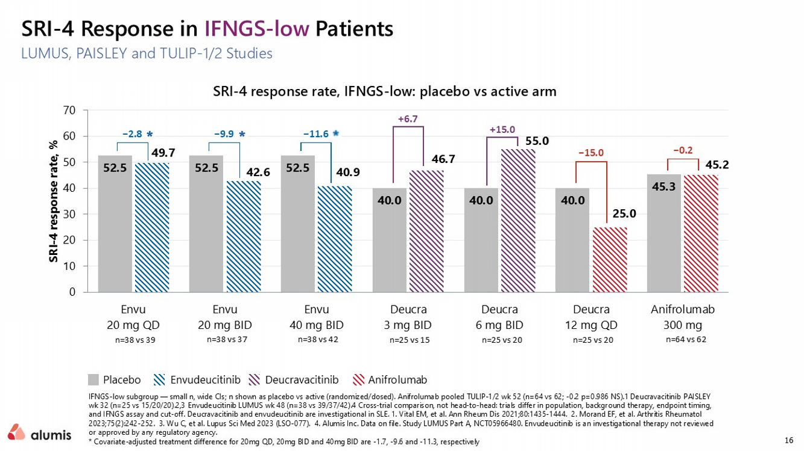
16 LUMUS, PAISLEY and TULIP - 1/2 Studies IFNGS - low subgroup — small n, wide CIs; n shown as placebo vs active (randomized/dosed). Anifrolumab pooled TULIP - 1/2 wk 52 (n=64 vs 62; - 0.2 p=0.986 NS).1 Deucravacitinib PAISLEY wk 32 (n=25 vs 15/20/20).2,3 Envudeucitinib LUMUS wk 48 (n=38 vs 39/37/42).4 Cross - trial comparison, not head - to - head: trials differ in population, background therapy, endpoint tim ing, and IFNGS assay and cut - off. Deucravacitinib and envudeucitinib are investigational in SLE. 1. Vital EM, et al. Ann Rheum Dis 2021;80:1435 - 1444. 2. Morand EF, et al. Arthritis Rheumatol 2023;75(2):242 - 252. 3. Wu C, et al. Lupus Sci Med 2023 (LSO - 077). 4. Alumis Inc. Data on file. Study LUMUS Part A, NCT05966480. Envudeucitinib is an investigational therapy not reviewed or approved by any regulatory agency. * Covariate - adjusted treatment difference​ for 20mg QD, 20mg BID and 40mg BID are - 1.7, - 9.6 and - 11.3, respectively SRI - 4 Response in IFNGS - low Patients 52.5 52.5 52.5 40.0 40.0 40.0 45.3 49.7 42.6 40.9 46.7 55.0 25.0 45.2 0 10 20 30 40 50 60 70 Envu 20 mg QD Envu 20 mg BID Envu 40 mg BID Deucra 3 mg BID Deucra 6 mg BID Deucra 12 mg QD Anifrolumab 300 mg SRI - 4 response rate, % SRI - 4 response rate, IFNGS - low: placebo vs active arm −2.8 −9.9 −11.6 +6.7 +15.0 −15.0 −0.2 n=38 vs 39 n=38 vs 37 n=38 vs 42 n=64 vs 62 n=25 vs 15 n=25 vs 20 n=25 vs 20 Placebo Deucravacitinib Anifrolumab Envudeucitinib

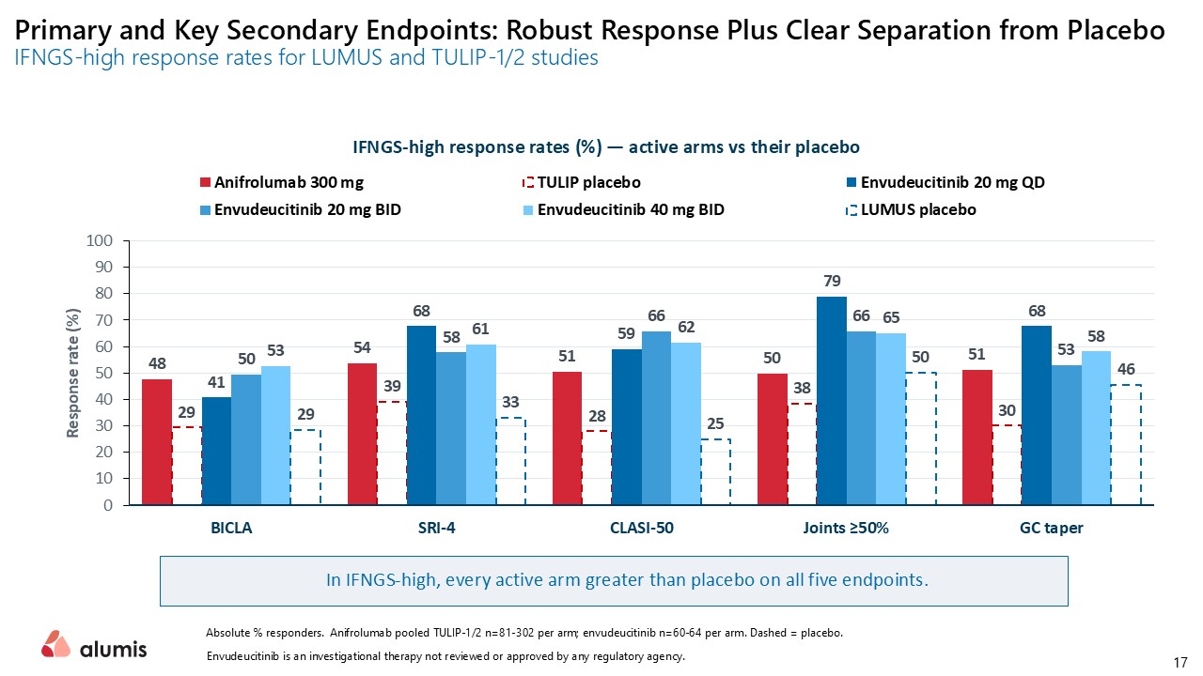
Primary and Key Secondary Endpoints: Robust Response Plus Clear Separation from Placebo IFNGS - high response rates for LUMUS and TULIP - 1/2 studies​ 48 54 51 50 51 29 39 28 38 30 41 68 59 79 68 50 58 66 66 53 53 61 62 65 58 29 33 25 50 46 0 10 20 30 40 50 60 70 80 90 100 BICLA SRI-4 CLASI-50 Joints ≥50% GC taper Response rate (%) IFNGS - high response rates (%) — active arms vs their placebo Anifrolumab 300 mg TULIP placebo Envudeucitinib 20 mg QD Envudeucitinib 20 mg BID Envudeucitinib 40 mg BID LUMUS placebo In IFNGS - high, every active arm greater than placebo on all five endpoints for both Absolute % responders. Anifrolumab pooled TULIP - 1/2 n= 81 - 302 per arm; envudeucitinib n= 60 - 64 per arm. Dashed = placebo. Envudeucitinib is an investigational therapy not reviewed or approved by any regulatory agency. 17

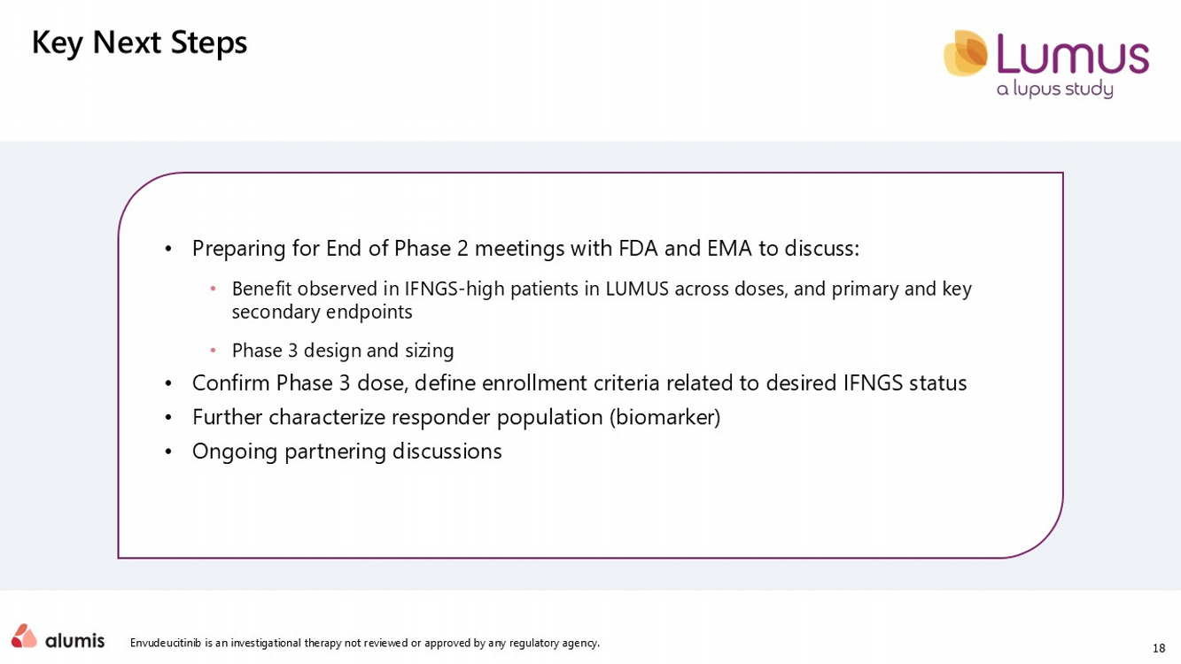
18 Envudeucitinib is an investigational therapy not reviewed or approved by any regulatory agency. Key Next Steps • Preparing for End of Phase 2 meetings with FDA and EMA to discuss: • Benefit observed in IFNGS - high patients in LUMUS across doses, and primary and key secondary endpoints • Phase 3 design and sizing • Confirm Phase 3 dose, define enrollment criteria related to desired IFNGS status • Further characterize responder population (biomarker) • Ongoing partnering discussions

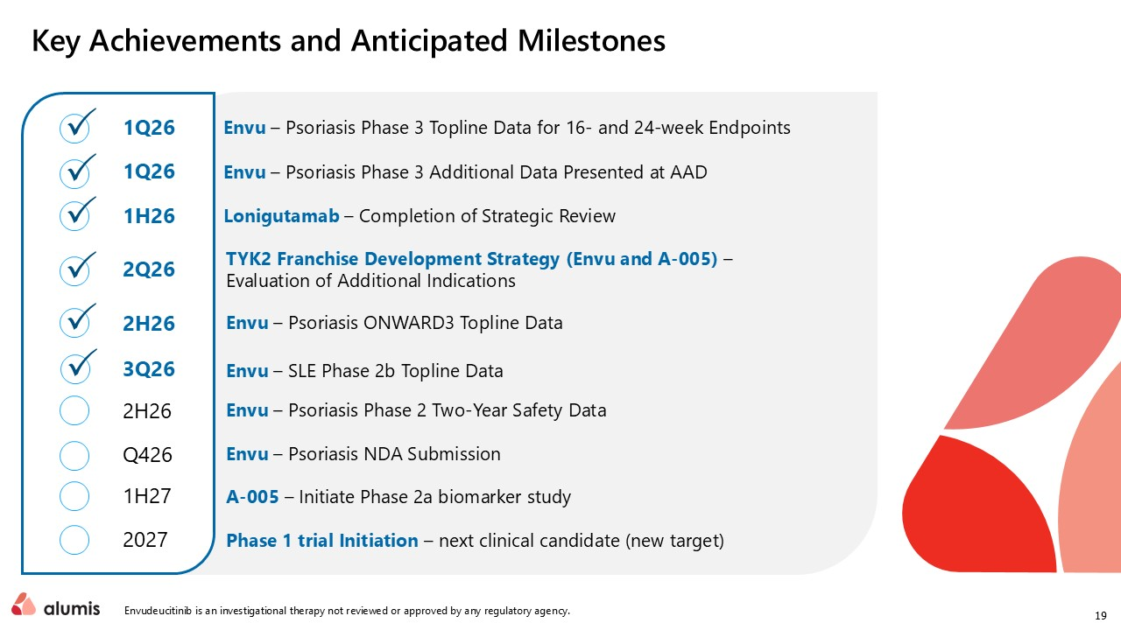
19 Key Achievements and Anticipated Milestones Envu – Psoriasis Phase 3 Topline Data for 16 - and 24 - week Endpoints Envu – Psoriasis Phase 3 Additional Data Presented at AAD Lonigutamab – Completion of Strategic Review TYK2 Franchise Development Strategy ( Envu and A - 005) – Evaluation of Additional Indications Envu – Psoriasis ONWARD3 Topline Data Envu – SLE Phase 2b Topline Data Envu – Psoriasis Phase 2 Two - Year Safety Data Envu – Psoriasis NDA Filing A - 005 – Initiate Phase 2a biomarker study Phase 1 trial Initiation – next clinical candidate (new target) 2Q26 2H26 3Q26 2H26 Q426 1H27 2027 1H26 1Q26 1Q26 Envudeucitinib is an investigational therapy not reviewed or approved by any regulatory agency.


Transform Therapies. Reimagine Lives. Thank You Q&A

